**Complete Element reference for Jmeter**

The different components of JMeter are called Elements. Each Element is designed for a specific purpose.

The figure below gives the some common elements in JMeter.

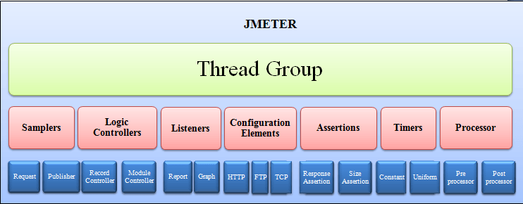

Studying all the componens at one go is an invitation to confusion and boredome. Here, we will discuss the must-know components before you can start Testing in JMeter.

Remaining components will be discussed as when they are used in the succeeding tutorials. The elements discussed in this tutorial are

* Thread Group
* Samplers
* Listeners
* Configuration

**Thread Group**

Thread Groups is a collection of Threads. Each thread represents one user using the application under test. Basically each Thread simulates one real user request to the server.

The controls for a thread group allow you to Set the number of threads for each group.

For example, if you set the number of threads as 100; JMeter will create and simulate 100 user requests to the server under test

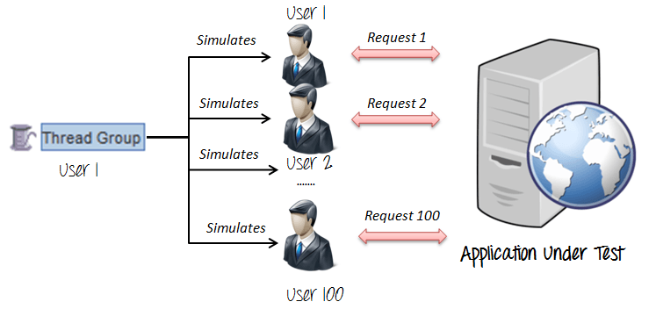

**Samplers**

As we know already that JMeter supports testing HTTP, FTP , JDBC and many other protocols.

We already know that Thread Groups simulate user request to the server

But how does a Thread Group know which type of requests (HTTP, FTP etc.) it needs to make ?

The answer is Samplers

The user request could be FTP Request, HTTP Request, JDBC Request...Etc.

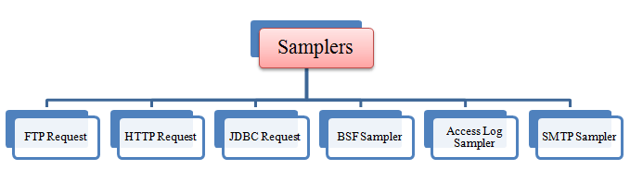

**FTP request:**

Let imagine you want to performance test an FTP server. You can use FTP request sampler in JMeter to do this task. This controller lets you send an FTP "download file" or "upload file" request to an FTP server.

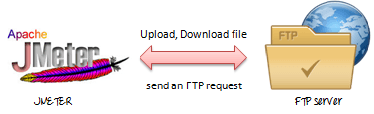

For example, if you want to download a file "Test.txt" from a FTP server under test, you need to configure some parameters in JMeter as figure below

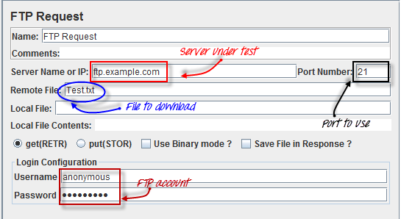

## HTTP request:

This sampler lets you send an HTTP/HTTPS request to a web server.

Consider the example below. JMeter send a HTTP request to Google website and retrieve HTML files or image from this website.



In the tutorial JMeter Performance Testing, we will explain more about this HTTP request.

## JDBC request:

This sampler lets you execute Database Performance Testing. It sends a JDBC Request (an SQL query) to a database.



For example, a database server has a field test_result stored in a table name test_tbl. You want to query this data from the database server; you can configure JMeter to send a SQL query to this server to retrieve data.

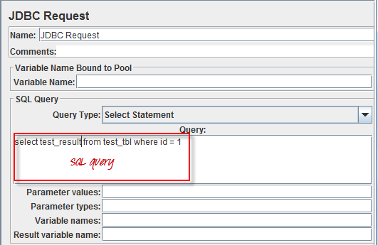

## BSF Sampler:

This sampler allows you to write a sampler using a BSF scripting language.

Here is an example of BSF  Sampler in JMeter

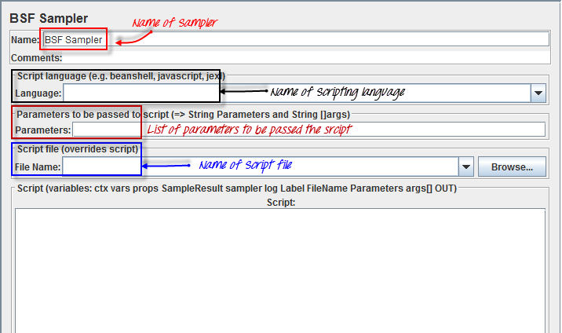

## Access Log Sampler:

This sampler allows you to read access logs and generate http requests. The log could be  image, html, css....

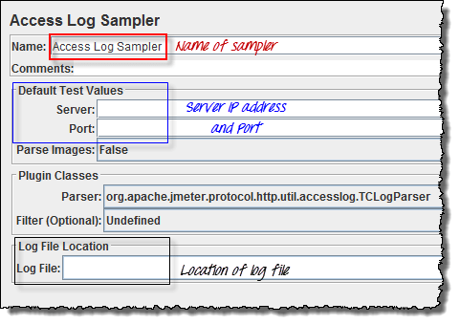

## SMTP Sampler:

If you want to test a mail server, you can use SMTP sampler. This sampler is used to send email messages using SMTP protocol.

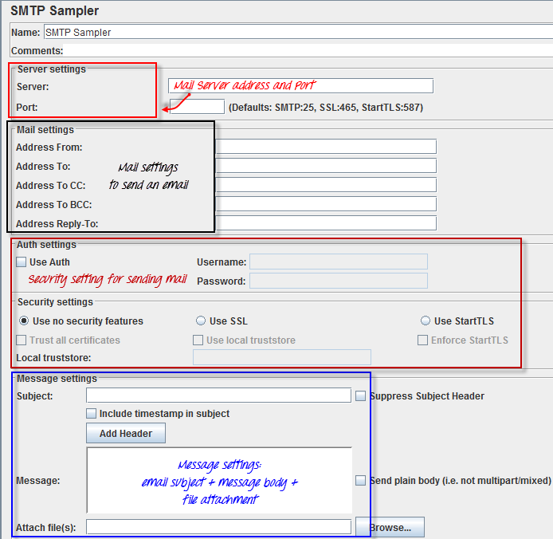

## Listeners

Listeners: shows the results of the test execution. They can show results in different format such as tree, table, graph or log file

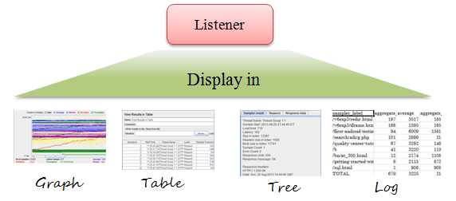

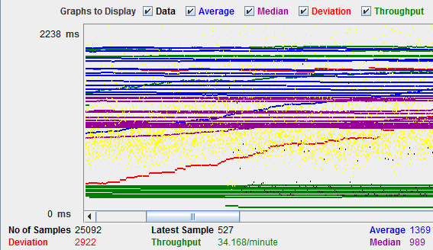

View Result Tree show results of user request in basic HTML format

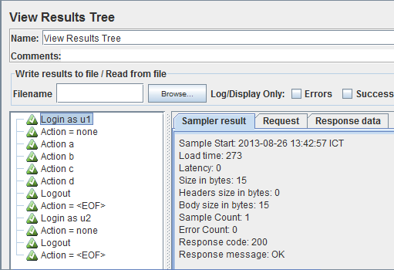

Table Result show summary of test result in table format

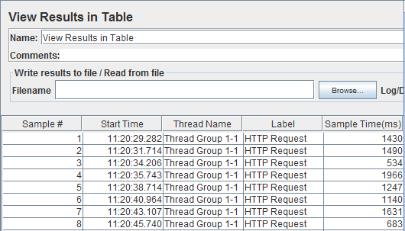

Log show summary of test result in the text file

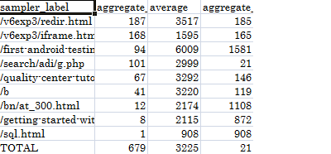

## Configuration Elements

set up defaults and variables for later use by samplers.

The figure below shows some commonly used configuration elements in JMeter

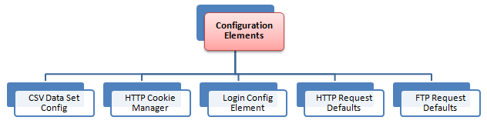

## CSV Data Set Config:

Suppose you want to test a website for 100 users signing-in with different credentials. You do not need to record the script 100 times! You can parameterization the script to enter different login credentials. This login information (e.g. Username, password) could be stored in a text file. JMeter has an element that allows you to read different parameters from that text file. It is "CSV Data Set Config", which is used to read lines from a file, and split them into variables.

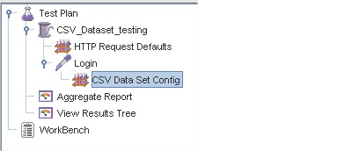

This is an example of CSV Data. It's a text file which contains user and password to login your target website

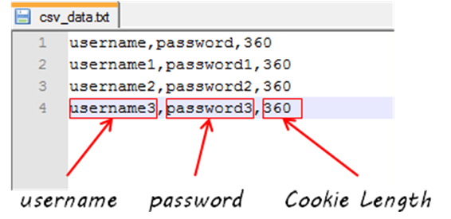

## HTTP Cookie Manager

Let's understand this with an example -

You used your browser (Firefox, IE...Etc) to browse www.google.com

You login with your user and password.

Your username and password will be stored in your computer as cookies.

HTTP Cookie Manager also has the same feature like a web browser. If you have an HTTP Request and the response contains a cookie, the Cookie Manager automatically stores that cookie and will use it for all future requests to that particular web site.

### HTTP request default

This element lets you set default values that your HTTP Request controllers use.

For example,

You are sending 100 HTTP requests to the server google.com

You would have to manually enter server name = google.com for all these 100 requests

Instead, you could add a single HTTP request defaults with the "Server Name or IP" field = google.com

No need to type 100 times!

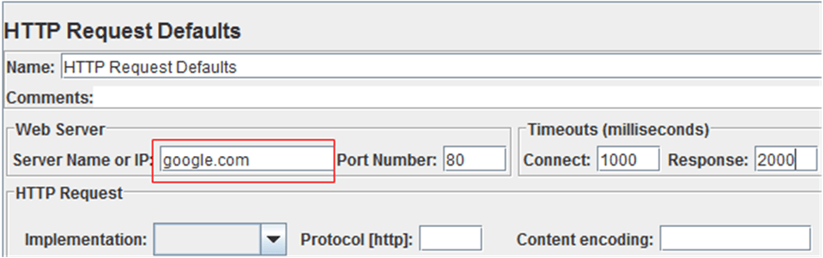

This element will be explained detail in tutorial JMeter Performance Testing

### Login Config Element

The Login Config Element lets you add or override username and password settings in samplers.

For example, you want to simulate one user login to website www.facebook.com with user and password. You can use Login Config Element to add these user and password setting in user request

The Login Config Element vs. the CSV data Config

|  |  |
| --- | --- |
| **Login Config Element** | **CSV Data Config** |
| Used to simulate one user login | Used to simulate multiple user login |
| Suitable for login parameter only (user and password) | Suitable for large numbers of parameters |